**Part 3 – WonderBurger**

|  |  |
| --- | --- |
| Name | Mathew Caldwell |
| ID | 20143330 |

WonderBurger

Demonstrate how to version control using GitHub. This includes collaborative workflows, and the process of resolving merge conflicts.

1. Go to <https://gist.github.com/prgrobots/7a906704222bbee86e59b041cdc5731e>
2. Complete the steps on the page.   
   Ensure you provide screen shot evidence of each step being completed in full this document.

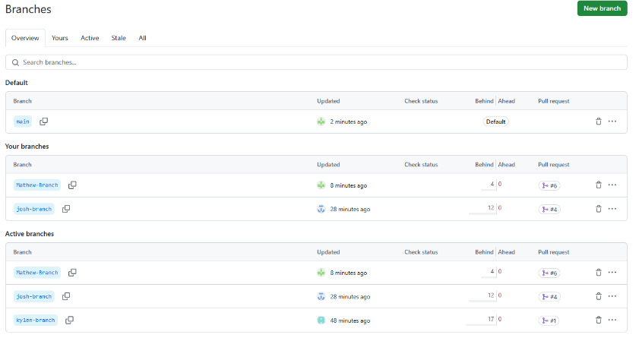Step 1.

Step 2

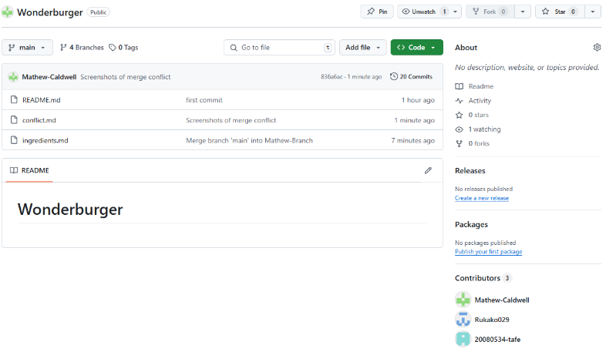

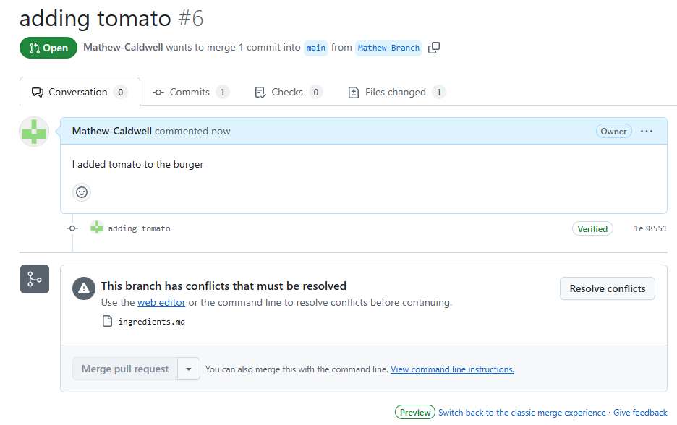Step 3.

Step 5.

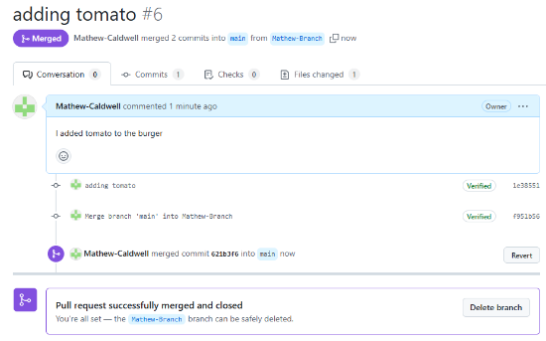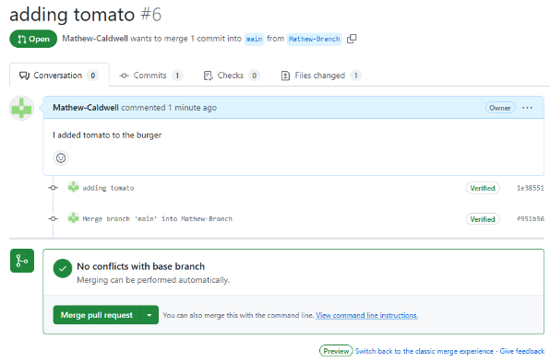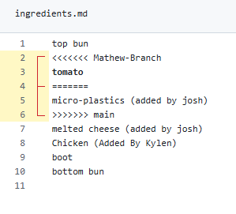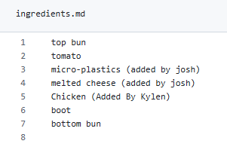

Step 6.

To create a better work flow that could have prevented merge conflicts, each team member could run a pull so they would then have the most updated version of everything.

Link to repo: <https://github.com/Mathew-Caldwell/Wonderburger>